Operating from the Albany County EOC

Antenna Drop:
The 2M/440Mhz dual band antenna lead (N connector with a jumper to PL-259) is located on the floor under one of the ‘teller’s stations’. See pictures below which show the location of the antenna drop and the operating position.

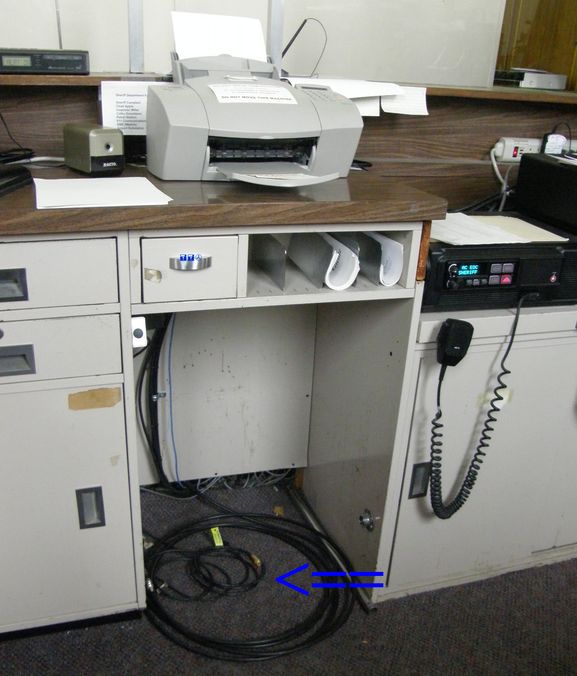 | 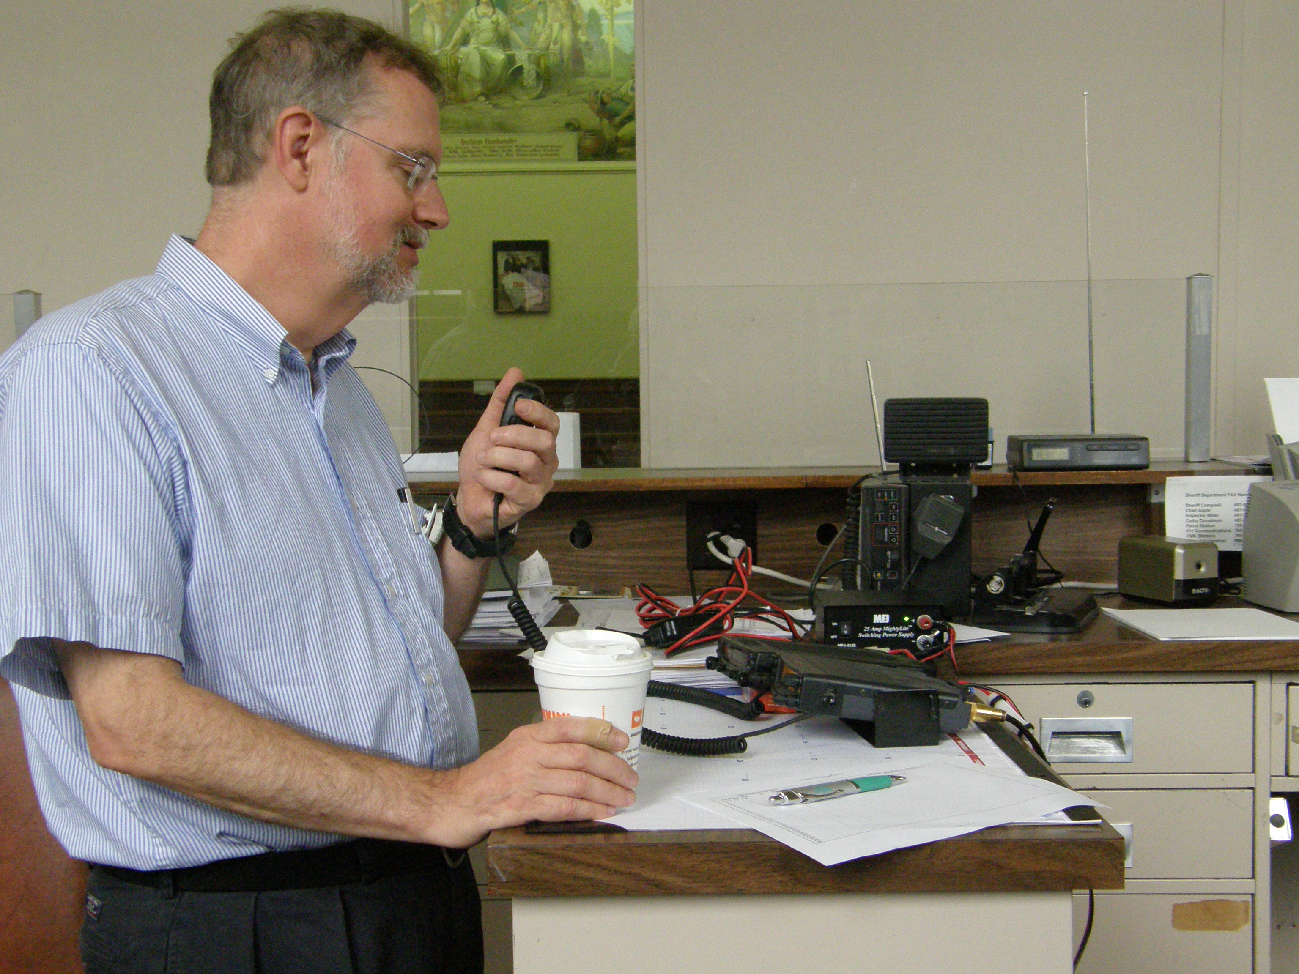

Equipment needed:
The minimum equipment required at this time is a 2M radio and power supply. It is highly recommended that a radio capable of receiving two 2M frequencies at the same time be used. The use of the external antenna is required since the inside of the EOC can not receive most repeaters even using mobile antennas inside the building.

